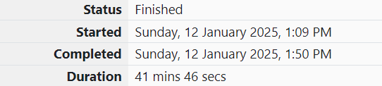

ROLL NO.:241801281

NAME: SUJITHA NEELAKANDAN VIGNESHWARI

WEEK 09-01

1.OBJECTIVE:

You are given a two-dimensional 3\*3 array starting from A [0][0]. You should add the alternate elements of the array and print its sum. It should print two different numbers the first being sum of A 0 0, A 0 2, A 1 1, A 2 0, A 2 2 and A 0 1, A 1 0, A 1 2, A 2 1.

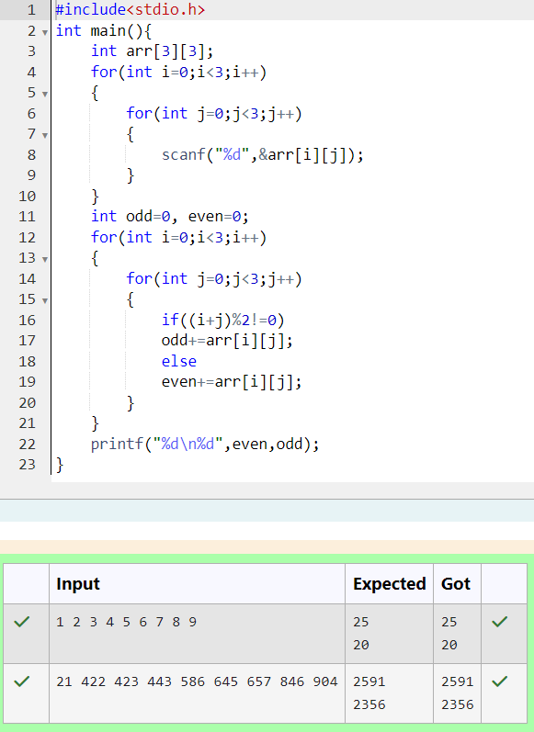CODE:

2.OBJECTIVE:

The task is to create a list where first all-female candidates are sorted in a descending order and then male candidates are sorted in a descending order.

CODE:

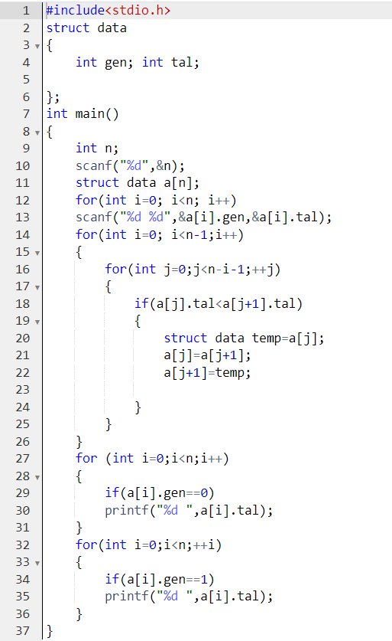

OUTPUT:

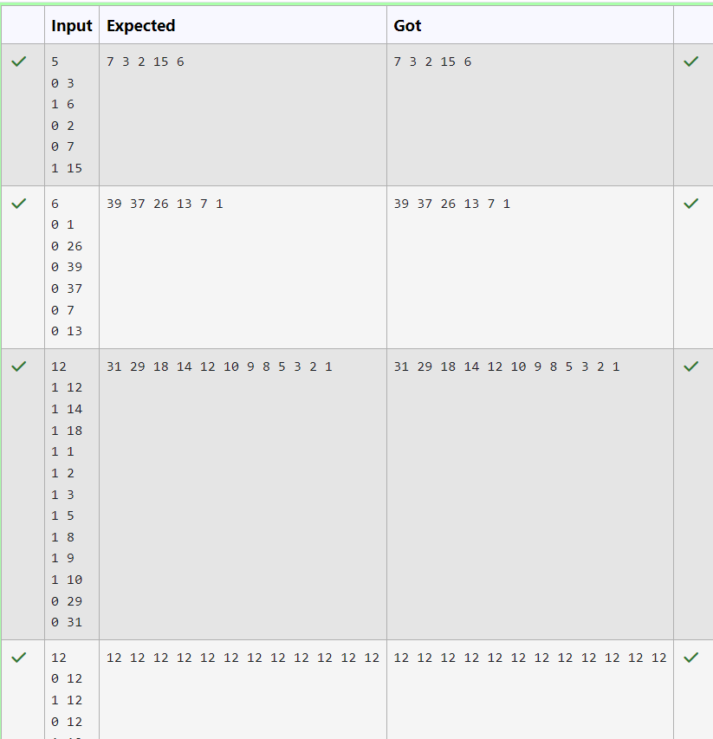

3.OBJECTIVE:

Print the total amount he has to return to farmers to solve the conflict.

CODE:

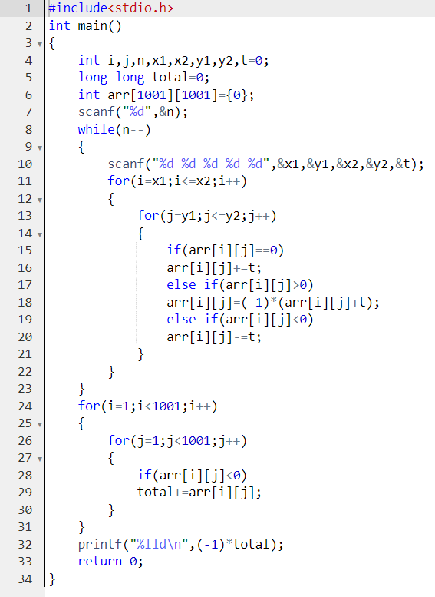

OUTPUT:

